21.49: a) For a wire of length 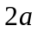 centered at the origin and lying along the y-axis, the electric field is given by Eq. (21.10).
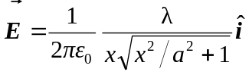
b) For an infinite line of charge:
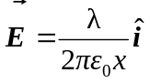
Graphs of electric field versus position for both are shown below.

